Home Worship Service for the Fourth Sunday in Lent

Instructions:
1. Print off this service
2. Go to holmensermons.blogspot.com
3. Click on the link that says “200322 Home Worship Service (Lent4).” A new window will open up and it should start playing immediately.
4. Follow along with this order of worship.

902 Lord Jesus Christ, Be Present Now
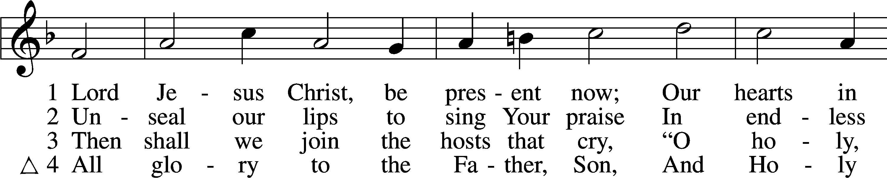
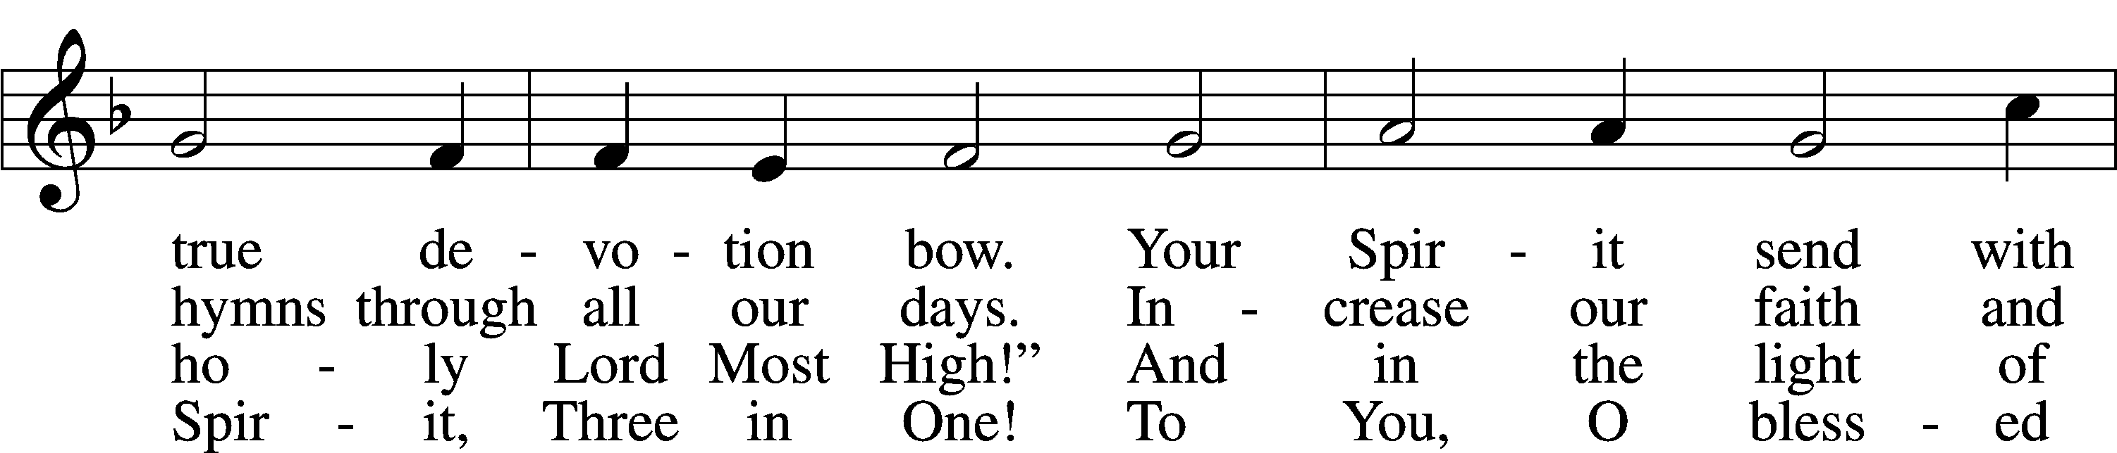
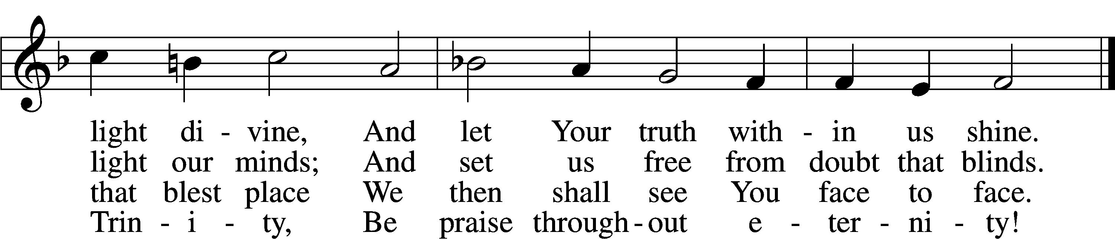
Tune and text: Public domain

Opening Versicles LSB 285
L O Lord, open my lips,
C and my mouth will declare Your praise.
L Make haste, O God, to deliver me;
C make haste to help me, O Lord.
Glory be to the Father and to the Son and to the Holy Spirit;
as it was in the beginning, is now, and will be forever. Amen.

First Reading: Exodus 16:2-21 The entire Israelite community grumbled against Moses and Aaron in the wilderness. ³The Israelites said to them, “If only we had died by the Lord’s hand in the land of Egypt, when we sat around pots of meat and ate as much food as we wanted, but now you have brought us out into this wilderness to have this whole community die of hunger.”
⁴Then the Lord said to Moses, “Watch what I will do. I will rain down bread from heaven for you, and the people will go out each day and gather enough for that day. In this way I will test whether they will follow my instructions or not. ⁵On the sixth day they will prepare what they bring in, and it will be twice as much as they gather on the other days.”
⁶So Moses and Aaron said to all the Israelites, “At evening you will know that it was the Lord who brought you out of the land of Egypt, ⁷and in the morning you will see the Glory of the Lord, because he has heard your constant grumbling against the Lord. Who are we that you should grumble against us?”
⁸Moses said, “Now the Lord will give you meat to eat in the evening and as much bread as you want in the morning, because the Lord has heard your grumbling against him. Who are we? Your grumbling is not against us but against the Lord.”
⁹Then Moses said to Aaron, “Tell the entire Israelite community, ‘Come before the Lord, because he has heard your grumbling.’” ¹⁰As Aaron spoke to the entire Israelite community, they turned toward the wilderness, and suddenly the Glory of the Lord appeared in the cloud.
¹¹The Lord spoke to Moses: ¹²“I have heard the grumbling of the Israelites. Say to them, ‘At evening you will eat meat, and in the morning you will eat bread until you are full. Then you will know that I am the Lord your God.’”
¹³So in the evening quail came and covered the camp, and in the morning a layer of dew surrounded the camp. ¹⁴When the layer of dew was gone, there were thin flakes on the surface of the wilderness, thin as frost on the ground. ¹⁵When the Israelites saw it, they said to one another, “What is it?” because they did not know what it was.
Moses said to them, “This is the bread which the Lord has given to you as food to eat. ¹⁶This is what the Lord has commanded: All of them are to gather as much of it as they need to eat. You are to take an omer per person based on the number of people each of you has in your tents.”
¹⁷The Israelites did this, and some gathered more, some less. ¹⁸When they measured it with an omer, the one who gathered more did not have too much, and the one who gathered less did not have too little. All of them gathered as much as they needed to eat. ¹⁹Moses said to them, “No one is to leave any of it until morning.” ²⁰However, they did not listen to Moses. Some of them left part of it until morning, and it became full of worms and stank. So Moses was angry with them.
²¹They gathered it each morning. All of them gathered as much as they needed to eat. When the sun grew hot, it melted away.
Second Reading:Acts 2:41-47 Those who accepted his message were baptized, and that day about three thousand people were added.
⁴²They continued to hold firmly to the apostles’ teaching and to the fellowship, to the breaking of the bread, and to the prayers. ⁴³Awe came over every soul, and many wonders and signs were being done through the apostles. ⁴⁴All the believers were together and had everything in common. ⁴⁵They were selling their possessions and property and were distributing the proceeds according to what anyone needed.
⁴⁶Day after day, with one mind, they were devoted to meeting in the temple area, as they continued to break bread in their homes. They shared their food with glad and sincere hearts, ⁴⁷as they continued praising God and being viewed favorably by all the people. Day after day the Lord added to their number those who were being saved.
Third Reading: John 6:1-15 After this, Jesus crossed over to the other side of the Sea of Galilee (or Tiberias). ²A large crowd followed him because they saw the miraculous signs he was performing on those who were sick. ³Jesus went up on the hillside and sat down there with his disciples. ⁴The Jewish Passover Festival was near.
⁵When Jesus looked up and saw a huge crowd coming toward him, he asked Philip, “Where can we buy bread for these people to eat?” ⁶But Jesus was saying this to test him, for he himself knew what he was going to do.
⁷Philip answered him, “Two hundred denarii worth of bread would not be enough for each of them to have just a little.”
⁸One of his disciples, Andrew, Simon Peter’s brother, said to him, ⁹“There’s a boy here who has five barley loaves and two fish, but what is that for so many people?”
¹⁰Jesus said, “Have the people sit down.” There was plenty of grass in that place, so they sat down. There were about five thousand men.
¹¹Then Jesus took the loaves and, after giving thanks, he distributed pieces to those who were seated. He also did the same with the fish—as much as they wanted.
¹²When the people were full, he told his disciples, “Gather the pieces that are left over so that nothing is wasted.” ¹³So they gathered them and filled twelve baskets with pieces from the five barley loaves left over by those who had eaten.
¹⁴When the people saw the miraculous sign Jesus did, they said, “This really is the Prophet who is coming into the world.”
¹⁵When Jesus realized that they intended to come and take him by force to make him king, he withdrew again to the mountain by himself.

743 Jesus, Priceless Treasure
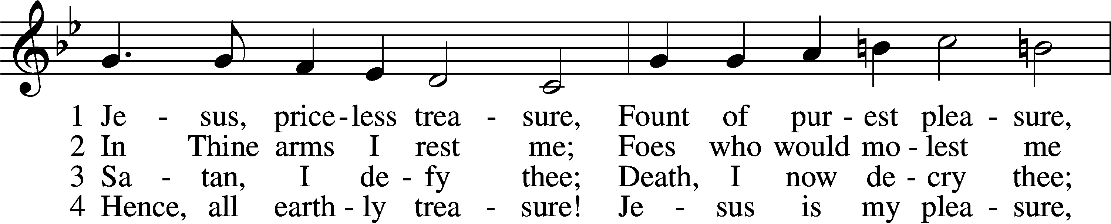
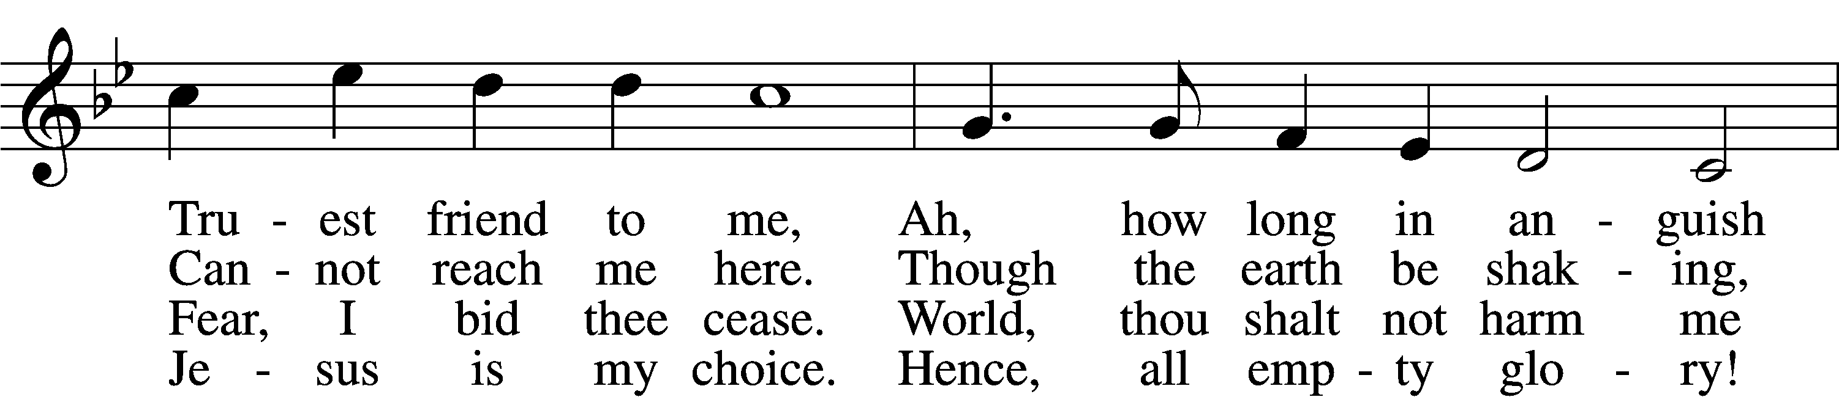
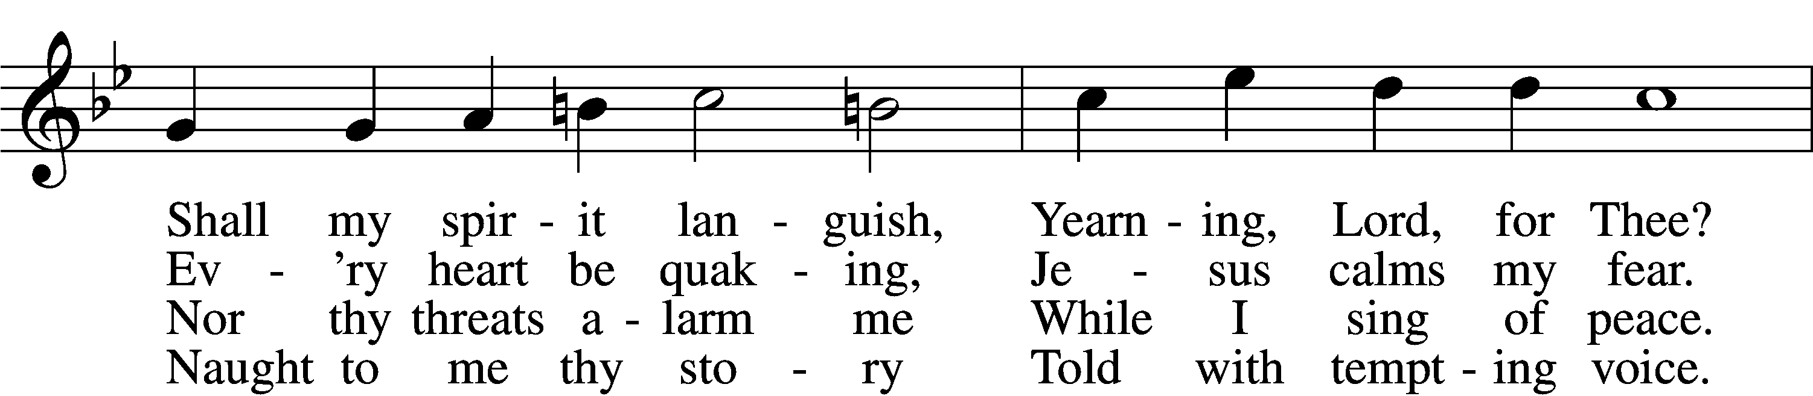
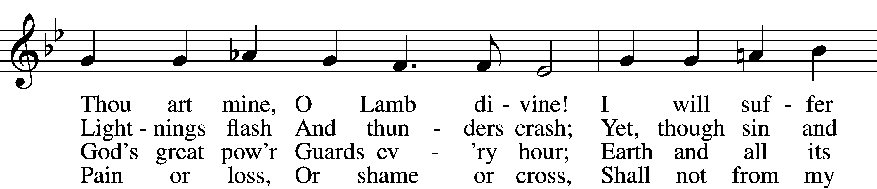
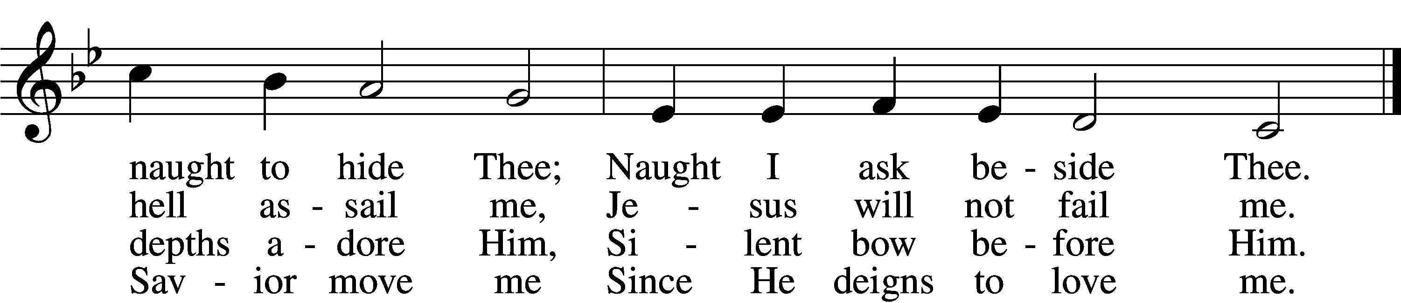

5 Evil world, I leave thee;
Thou canst not deceive me,
Thine appeal is vain.
Sin that once did blind me,
Get thee far behind me,
Come not forth again.
Past thy hour,
O pride and pow’r;
Sinful life, thy bonds I sever,
Leave thee now forever.

6 Hence, all fear and sadness!
For the Lord of gladness,
Jesus, enters in.
Those who love the Father,
Though the storms may gather,
Still have peace within.
Yea, whate’er
I here must bear,
Thou art still my purest pleasure,
Jesus, priceless treasure!
Text and tune: Public domain

Sermon

Kyrie LSB 285
L O Lord,
C have mercy.
L O Christ,
C have mercy.
L O Lord,
C have mercy.

Lord’s Prayer
C Our Father who art in heaven,
hallowed be Thy name,
Thy kingdom come,
Thy will be done on earth
as it is in heaven;
give us this day our daily bread;
and forgive us our trespasses
as we forgive those
who trespass against us;
and lead us not into temptation,
but deliver us from evil.
For Thine is the kingdom
and the power and the glory
forever and ever. Amen.

Apostles’ Creed
C I believe in God, the Father Almighty,
maker of heaven and earth.

And in Jesus Christ, His only Son, our Lord,
who was conceived by the Holy Spirit,
born of the virgin Mary,
suffered under Pontius Pilate,
was crucified, died and was buried.
He descended into hell.
The third day He rose again from the dead.
He ascended into heaven
and sits at the right hand of God the Father Almighty.
From thence He will come to judge the living and the dead.

I believe in the Holy Spirit,
the holy Christian Church,
the communion of saints,
the forgiveness of sins,
the resurrection of the body,
and the life T everlasting. Amen.

Versicles LSB 286
L Hear my prayer, O Lord;
C let my cry come to You.
L In the day of my trouble I call upon You,
C for You answer me.
L Hide Your face from my sins,
C and blot out all my iniquities.
L Create in me a clean heart, O God,
C and renew a right spirit within me.
L Cast me not away from Your presence,
C and take not Your Holy Spirit from me.
L Restore to me the joy of Your salvation,
C and uphold me with a willing spirit.
L Because Your steadfast love is better than life,
C my lips will praise You.
L For You have been my help,
C and in the shadow of Your wings I will sing for joy.
L Teach me Your way, O Lord, that I may walk in Your truth;
C unite my heart to fear Your name.
L I give thanks to You, O Lord my God, with my whole heart,
C and I will glorify Your name forever.
L May all who seek You rejoice and be glad in You.
C May those who love Your salvation say evermore, “God is great!”
L Save Your people and bless Your heritage!
C Be their shepherd and carry them forever.
L Give ear, O Lord, to my prayer;
C listen to my plea for grace.

Collect of the Day
L Let us pray.
Almighty God, our heavenly Father, Your mercies are new every morning; and though we deserve only punishment, You receive us as Your children and provide for all our needs of body and soul. Grant that we may heartily acknowledge Your merciful goodness, give thanks for all Your benefits, and serve You in willing obedience; through Jesus Christ, Your Son, our Lord, who lives and reigns with You and the Holy Spirit, one God, now and forever.
C Amen.
L Almighty God, heavenly Father, give us grace to trust You during this time of illness and distress. In mercy put an end to the pandemic that afflicts us. Grant relief to those who suffer, and comfort to all who mourn. Sustain all medical personnel in their labors, and cause Your people ever to serve You in righteousness and holiness; through Jesus Christ, Your Son, our Lord, who lives and reigns with You and the Holy Spirit, one God, now and forever.
C Amen.

C I thank You, my heavenly Father, through Jesus Christ, Your dear Son, that You have kept me this night from all harm and danger; and I pray that You would keep me this day also from sin and every evil, that all my doings and life may please You. For into Your hands I commend myself, my body and soul, and all things. Let Your holy angel be with me, that the evil foe may have no power over me. Amen.

Benedicamus LSB 287
L Let us bless the Lord.
C Thanks be to God.

Blessing LSB 287
L The Lord bless us, defend us from all evil, and bring us to everlasting life.
C Amen.
770 What a Friend We Have in Jesus
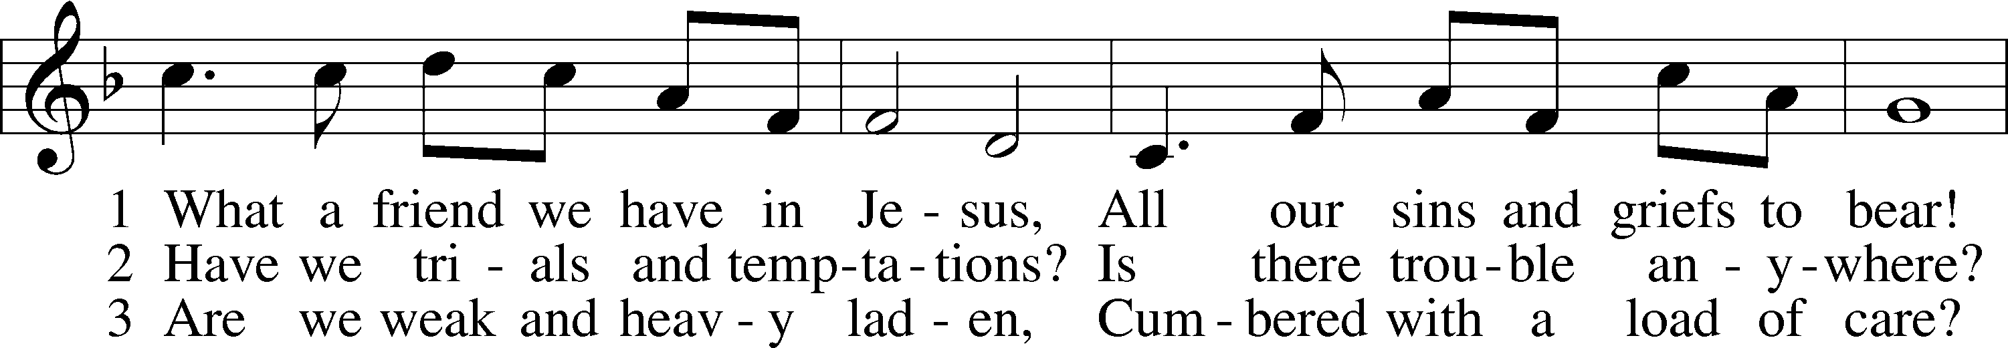
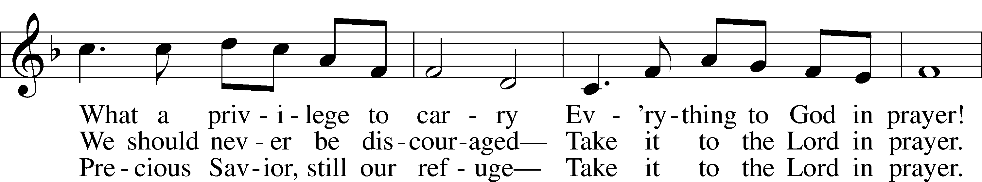
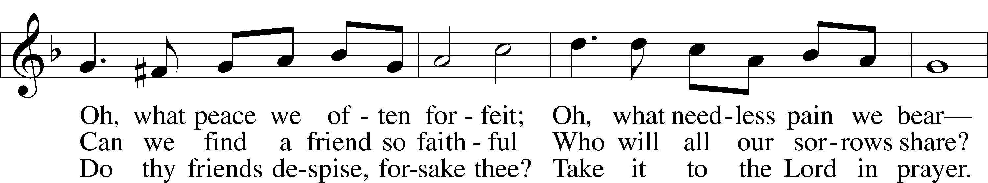
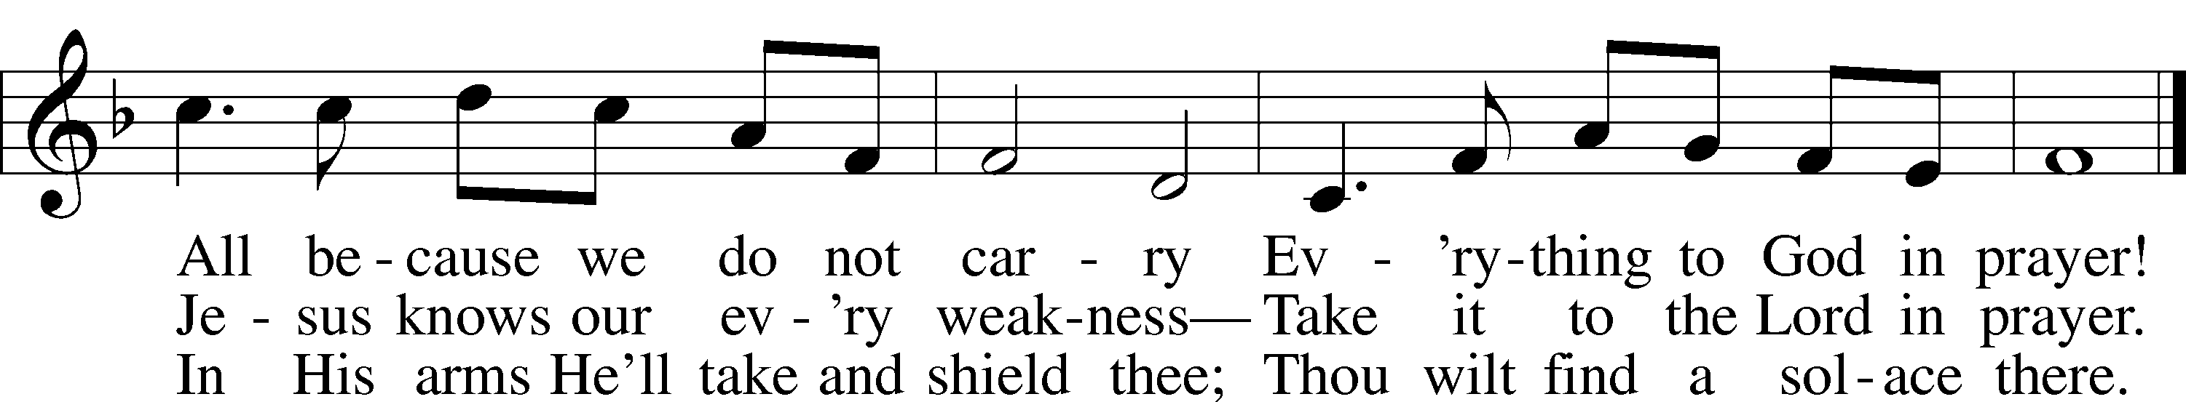
Tune and text: Public domain

