Home Worship Service for the Fifth Sunday in Lent
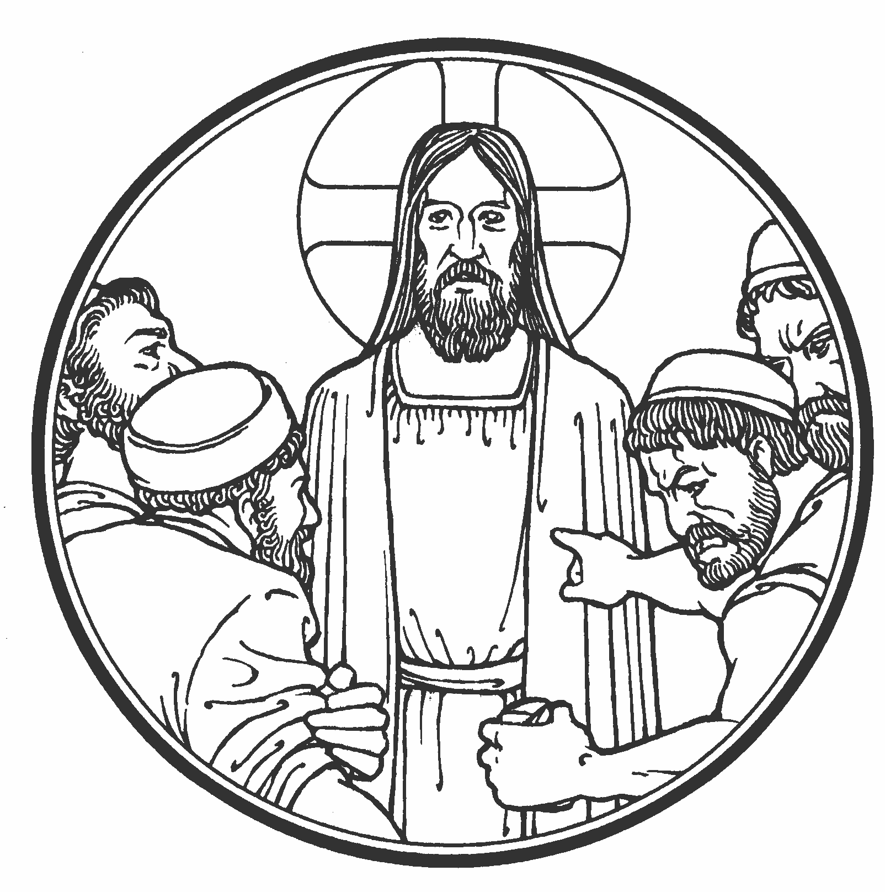

Instructions:
1. Print off this service
2a. Click on link in email
OR
2b. Go to holmensermons.blogspot.com. Click on the link that says “200329 Home Worship Service (Lent 5).” A new window will open up and it should start playing immediately.
4. Follow along with this order of worship.

547 The Lamb
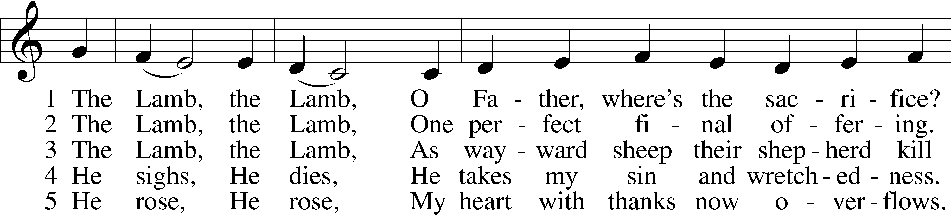
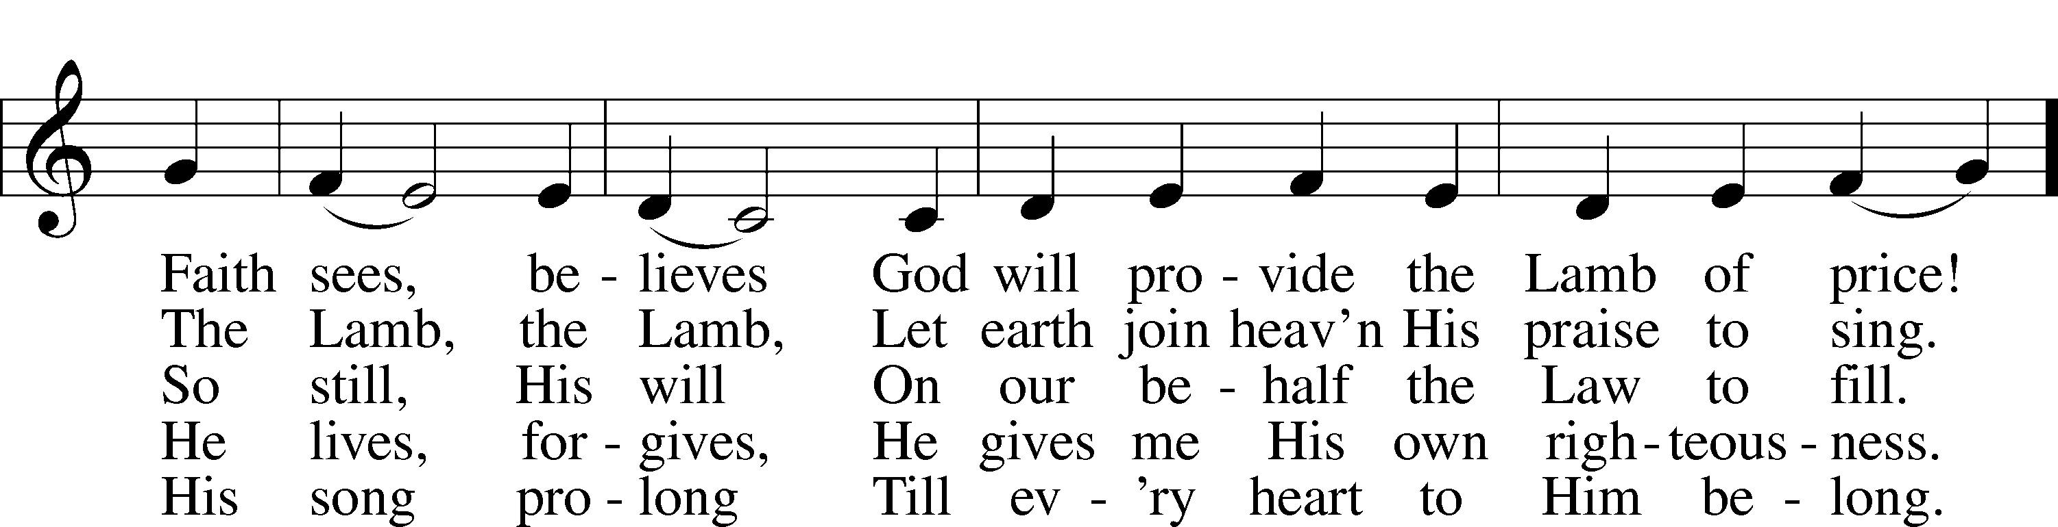
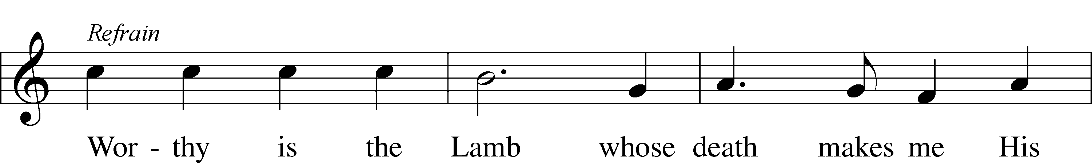
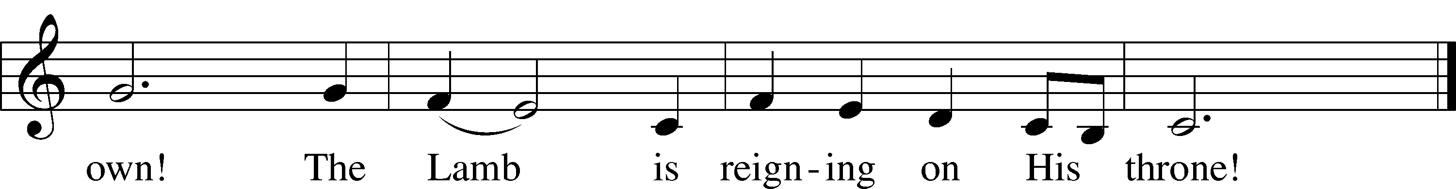
Text and tune: © 1987 and 1997 MorningStar Music Publishers. Used by permission: CPH Limited Promotional License no. 119000000

Opening Versicles LSB 285
L O Lord, open my lips,
C and my mouth will declare Your praise.
L Make haste, O God, to deliver me;
C make haste to help me, O Lord.
Glory be to the Father and to the Son and to the Holy Spirit;
as it was in the beginning, is now, and will be forever. Amen.

First Reading: Genesis 22:1-14
Some time later God tested Abraham. He called to him, “Abraham!”
Abraham answered, “I am here.”
²God said, “Now take your son, your only son, whom you love, Isaac, and go to the land of Moriah. Offer him there as a burnt offering on one of the mountains there, the one to which I direct you.”
³Abraham got up early in the morning, saddled his donkey, and took two of his young men with him, along with Isaac his son. Abraham split the wood for the burnt offering. Then he set out to go to the place that God had told him about. ⁴On the third day Abraham looked up and saw the place in the distance.
⁵Abraham said to his young men, “Stay here with the donkey. The boy and I will go on over there. We will worship, and then we will come back to you.” ⁶Abraham took the wood for the burnt offering and loaded it on Isaac his son. He took the firepot and the knife in his hand. The two of them went on together.
⁷Isaac spoke to Abraham his father and said, “My father?”
He said, “I am here, my son.”
He said, “Here are the fire and the wood, but where is the lamb for a burnt offering?”
⁸Abraham said, “God himself will provide the lamb for a burnt offering, my son.” So the two of them went on together. ⁹They came to the place that God had told him about. Abraham built the altar there. He arranged the wood, tied up Isaac his son, and laid him on the altar on top of the wood. ¹⁰Abraham stretched out his hand and took the knife to slaughter his son.
¹¹The Angel of the Lord called to him from heaven, “Abraham, Abraham!”
Abraham said, “I am here.”
¹²He said, “Do not lay your hand on the boy. Do not do anything to him. For now I know that you fear God, because you have not withheld your son, your only son, from me.”
¹³Abraham looked around and saw that behind him there was a ram caught in the thicket by its horns. Abraham went and took the ram and offered it up as a burnt offering instead of his son. ¹⁴Abraham called the name of that place “The Lord Will Provide.” So it is said to this day, “On the mountain of the Lord it will be provided.”
Second Reading: Hebrews 9:11-15
But when Christ appeared as the high priest of the good things that were coming, he went through the greater and more complete tent, which was not made by human hands (that is, it is not part of this creation). ¹²He entered once into the Most Holy Place and obtained eternal redemption, not by the blood of goats and calves, but by his own blood. ¹³Now if the blood of goats and bulls and the ashes of a heifer, sprinkled on those who were unclean, sanctifies them so that their flesh is clean, ¹⁴how much more will the blood of Christ, who through the eternal Spirit offered himself without blemish to God, cleanse our consciences from dead works, so that we worship the living God?
¹⁵For this reason, he is the mediator of a new covenant. A death took place as payment for the trespasses committed under the first covenant, so that those who are called would receive the promised eternal inheritance.
Third Reading: John 8:42-59
Jesus replied, “If God were your Father, you would love me, because I came from God and I am here. Indeed, I have not come on my own, but he sent me. ⁴³Why do you not understand my message? It is because you are not able to listen to my word. ⁴⁴You belong to your father, the Devil, and you want to do your father’s desires. He was a murderer from the beginning and did not remain standing in the truth, because there is no truth in him. Whenever he lies, he speaks from what is his, because he is a liar and the father of lying. ⁴⁵But because I tell the truth, you do not believe me.
⁴⁶“Who of you can convict me of sin? If I am telling the truth, why don’t you believe me? ⁴⁷Whoever belongs to God listens to what God says. The reason you do not listen is that you do not belong to God.”
⁴⁸The Jews responded, “Are we not right in saying that you are a Samaritan and have a demon?”
⁴⁹Jesus answered, “I do not have a demon. On the contrary, I honor my Father, and you dishonor me. ⁵⁰I do not seek my own glory. There is one who seeks it, and he is the judge. ⁵¹Amen, Amen, I tell you: If anyone holds on to my word, he will certainly never see death.”
⁵²So the Jews said to him, “Now we know that you have a demon. Abraham died, and so did the prophets. Yet you say, ‘If anyone holds on to my word, he will certainly never taste death.’ ⁵³You are not greater than our father, Abraham, are you? He died. And the prophets died. Who do you think you are?”
⁵⁴Jesus answered, “If I glorify myself, my glory is nothing. It is my Father who glorifies me, about whom you say, ‘He is our God.’ ⁵⁵Yet you do not really know him, but I do know him. If I said, ‘I do not know him,’ I would be a liar like you. But I do know him, and I hold on to his word. ⁵⁶Your father Abraham was glad that he would see my day. He saw it and rejoiced.”
⁵⁷The Jews replied, “You aren’t even fifty years old, and you have seen Abraham?”
⁵⁸Jesus said to them, “Amen, Amen, I tell you: Before Abraham was born, I am.” ⁵⁹Then they picked up stones to throw at him. But Jesus was hidden and left the temple area.

430 My Song Is Love Unknown
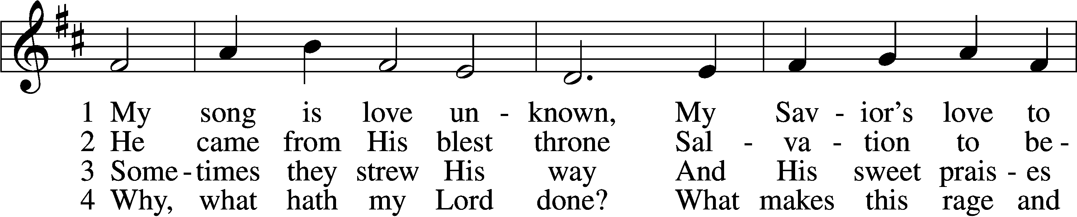
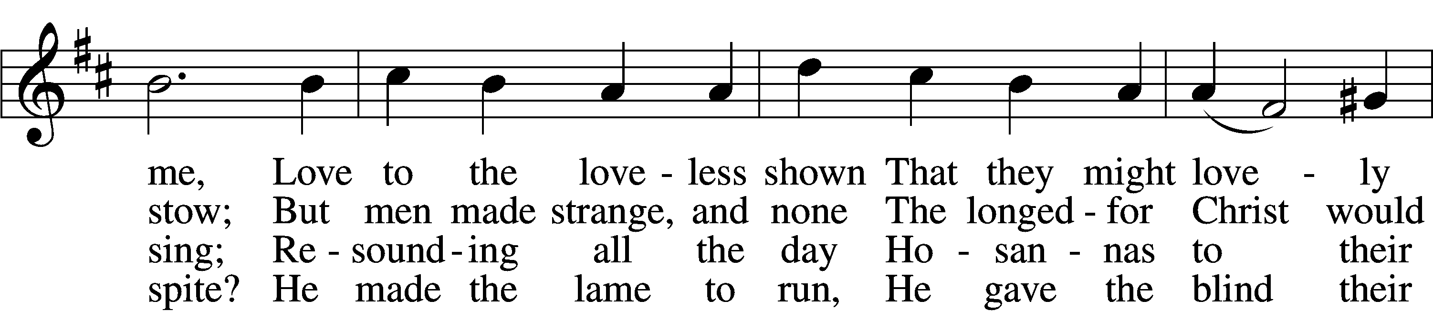
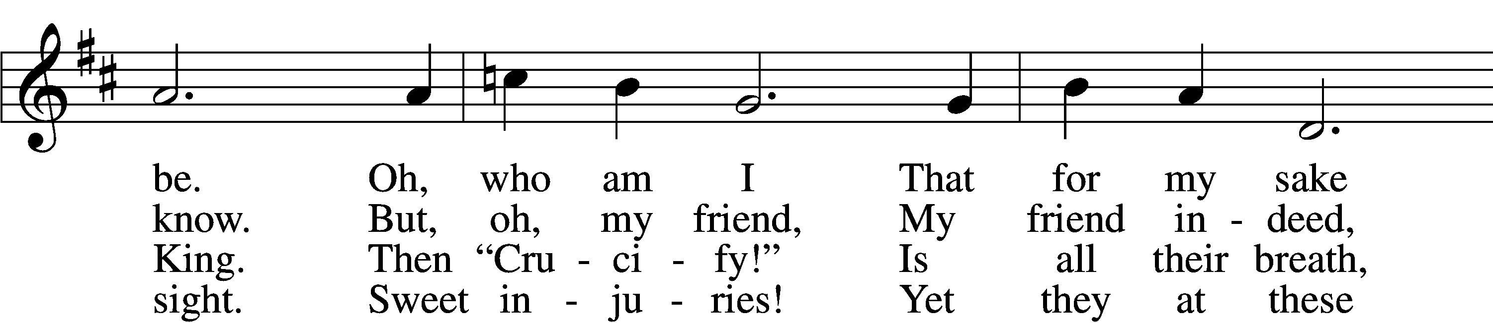
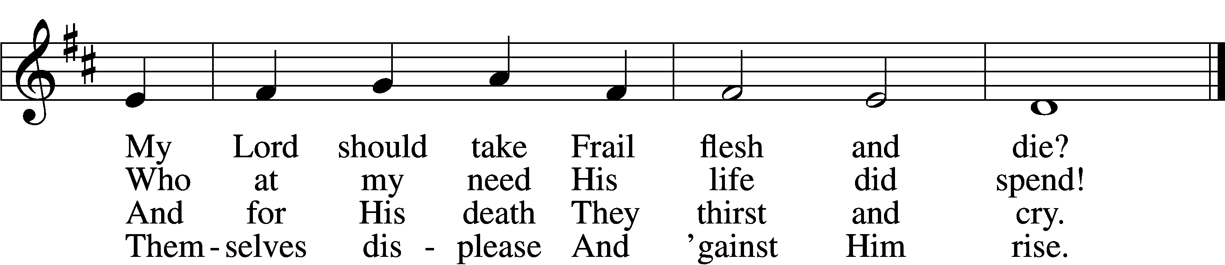

5 They rise and needs will have
My dear Lord made away;
A murderer they save,
The Prince of Life they slay.
Yet cheerful He
To suff’ring goes
That He His foes
From thence might free.

6 In life no house, no home
My Lord on earth might have;
In death no friendly tomb
But what a stranger gave.
What may I say?
Heav’n was His home
But mine the tomb
Wherein He lay.

7 Here might I stay and sing,
No story so divine!
Never was love, dear King,
Never was grief like Thine.
This is my friend,
In whose sweet praise
I all my days
Could gladly spend!
Tune: © John Ireland Trust. Used by permission: CPH Limited Promotional License no. 119000000
Text: Public domain

Sermon

Kyrie LSB 285
L O Lord,
C have mercy.
L O Christ,
C have mercy.
L O Lord,
C have mercy.

Lord’s Prayer
C Our Father who art in heaven,
hallowed be Thy name,
Thy kingdom come,
Thy will be done on earth
as it is in heaven;
give us this day our daily bread;
and forgive us our trespasses
as we forgive those
who trespass against us;
and lead us not into temptation,
but deliver us from evil.
For Thine is the kingdom
and the power and the glory
forever and ever. Amen.

Apostles’ Creed
C I believe in God, the Father Almighty,
maker of heaven and earth.

And in Jesus Christ, His only Son, our Lord,
who was conceived by the Holy Spirit,
born of the virgin Mary,
suffered under Pontius Pilate,
was crucified, died and was buried.
He descended into hell.
The third day He rose again from the dead.
He ascended into heaven
and sits at the right hand of God the Father Almighty.
From thence He will come to judge the living and the dead.

I believe in the Holy Spirit,
the holy Christian Church,
the communion of saints,
the forgiveness of sins,
the resurrection of the body,
and the life T everlasting. Amen.

Versicles LSB 286
L Hear my prayer, O Lord;
C let my cry come to You.
L In the day of my trouble I call upon You,
C for You answer me.
L Hide Your face from my sins,
C and blot out all my iniquities.
L Create in me a clean heart, O God,
C and renew a right spirit within me.
L Cast me not away from Your presence,
C and take not Your Holy Spirit from me.
L Restore to me the joy of Your salvation,
C and uphold me with a willing spirit.
L Because Your steadfast love is better than life,
C my lips will praise You.
L For You have been my help,
C and in the shadow of Your wings I will sing for joy.
L Teach me Your way, O Lord, that I may walk in Your truth;
C unite my heart to fear Your name.
L I give thanks to You, O Lord my God, with my whole heart,
C and I will glorify Your name forever.
L May all who seek You rejoice and be glad in You.
C May those who love Your salvation say evermore, “God is great!”
L Save Your people and bless Your heritage!
C Be their shepherd and carry them forever.
L Give ear, O Lord, to my prayer;
C listen to my plea for grace.

Collect of the Day
L Let us pray.
Almighty God, by Your great goodness mercifully look upon Your people that we may be governed and preserved evermore in body and soul; through Jesus Christ, Your Son, our Lord, who lives and reigns with You and the Holy Spirit, one God, now and forever.
C Amen.
L Almighty God, heavenly Father, give us grace to trust You during this time of illness and distress. In mercy put an end to the pandemic that afflicts us. Grant relief to those who suffer, and comfort to all who mourn. Sustain all medical personnel in their labors, and cause Your people ever to serve You in righteousness and holiness; through Jesus Christ, Your Son, our Lord, who lives and reigns with You and the Holy Spirit, one God, now and forever.
C Amen.

C I thank You, my heavenly Father, through Jesus Christ, Your dear Son, that You have kept me this night from all harm and danger; and I pray that You would keep me this day also from sin and every evil, that all my doings and life may please You. For into Your hands I commend myself, my body and soul, and all things. Let Your holy angel be with me, that the evil foe may have no power over me. Amen.

Benedicamus LSB 287
L Let us bless the Lord.
C Thanks be to God.

Blessing LSB 287
L The Lord bless us, defend us from all evil, and bring us to everlasting life.
C Amen.
431 Not All the Blood of Beasts
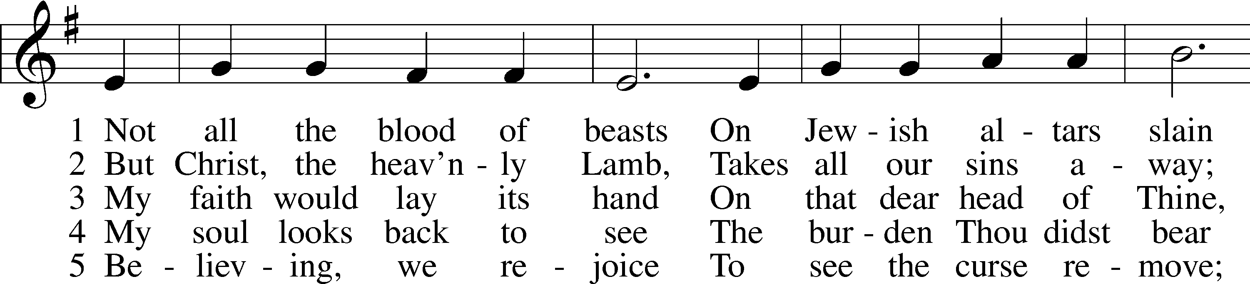
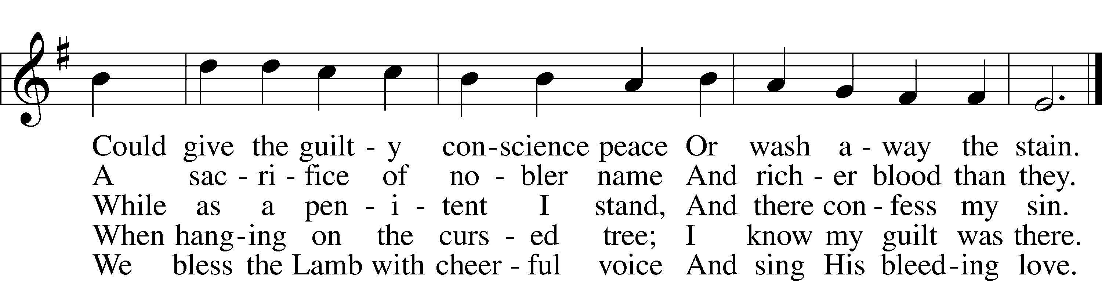
Tune and text: Public domain

